KRAS Kickers Title Page

Ying Zhou
Emily Tran
Chris Conneran
Daniel Brannock

Table of Contents
Table of Contents 2
Executive Summary 3
Current System 4
Recommendations for New System 5
Implementation Plan 6
Appendix 7
Appendix [Internal] 8
Models 8
Ongoing Concerns 8
Plan Presentation 8
Lessons Learned 8

Executive Summary
[Point person: Daniel]

Background
KRAS Kickers is a patient-driven nonprofit intended to serve the community of people impacted by cancers linked to the KRAS oncogene. Their mission is focused on democratizing knowledge about KRAS cancers, sharing recent research and resources, advocating for patients, and promoting science and survivorship. They do not fund research; rather, they educate, empower, and engage with patients and caregivers as they navigate the rapidly advancing treatment landscape available to those with KRAS cancers. The organization is growing quickly and needs a new system for managing and coordinating volunteerism.

Current State

Proposed State

Implementation Plan

Current System
[Point person: Ying]
Overview
To understand the current volunteer coordination and engagement system used by KRAS Kickers, our team modeled the workflow based on interviews with stakeholders and observations of existing processes. We selected a workflow model to represent the current system, as it clearly outlines the operational sequence, roles, and information flows involved in volunteer recruitment, assignment, and project support.
Current Workflow Model
Workflow for Volunteer Coordination (Current State)
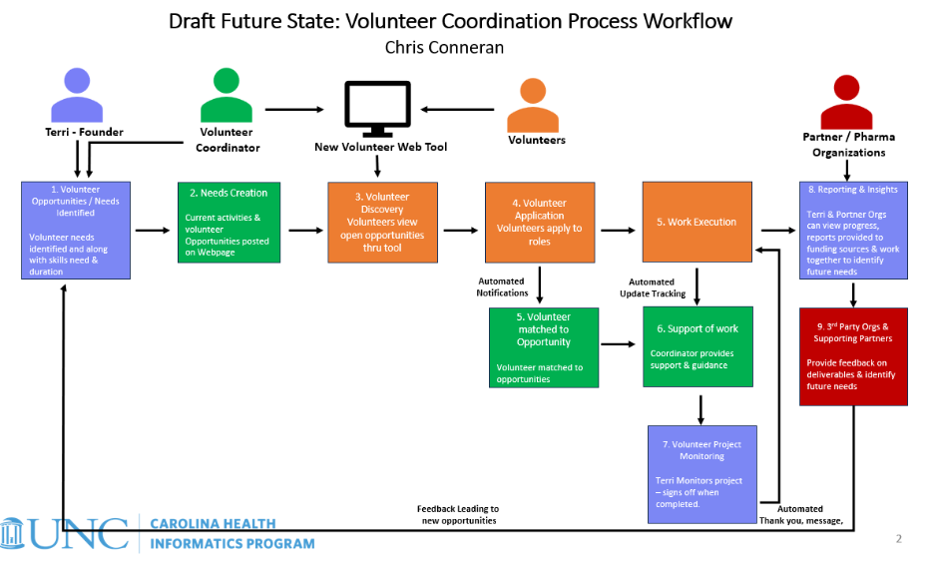
The current workflow illustrates how volunteer needs are identified, posted, and fulfilled within the organization. The process begins when the founder identifies volunteer needs and the volunteer coordinator posts available opportunities. Volunteers then review and apply for roles, after which the coordinator evaluates applications, assigns volunteers, and monitors project execution. Progress updates and feedback are shared between volunteers, the coordinator, and partner organizations, supporting ongoing communication and quality assurance.
This model highlights both automated and manual touchpoints, showing where technology assists coordination (e.g., posting opportunities, automated notifications) and where human oversight ensures successful engagement (e.g., reviewing applications, providing ongoing support).
Information Sources
This workflow reflects combined insights from:
- Interview with Terri Conneran, KRAS Kickers Founder
- Interview with Patty McConnell, KRAS Kickers Event Coordination
- Interview with Hannah Conneran, KRAS Kickers Content Manager
- Interview with Hope Given, KRAS Kickers Patient Outreach
- Input and process knowledge from Chris Conneran, based on existing operations and research on volunteer coordination practices in similar nonprofit organizations
Rationale for Using Workflow Modeling
We chose the workflow model because it clearly demonstrates how the current volunteer system functions, where communication and coordination occur, and where bottlenecks or inefficiencies may arise. By visually mapping the process, we are able to:
- Identify inefficiencies in manual steps (e.g., volunteer matching and follow-up)
- Understand key stakeholder roles and system dependencies
- Recognize opportunities for improved automation and data tracking
- Provide a structured foundation for designing system enhancements
This workflow also allows us to iteratively refine our understanding of the system. As we gather feedback and continue our analysis, the model can be updated to better reflect process realities and guide recommendations for the future system design.

Recommendations for New System
[Point person: Emily]
Our team came together and suggested four possible recommendations for a new volunteer system that will improve volunteer screening, management, and communication.
Recommendation 1: Hiring of a Volunteer Coordinator and Volunteer Management App
GivePulse is a volunteer management app that helps organizations manage their volunteers with ease. These are the functions of the app:
- Organize and monitor volunteer interactions and participation
- Send mass communication messages to volunteers about information, updates, etc.
- Create and message specific subgroups
- Volunteer application portal
- Database of volunteer information, applications, donations – allows for searching, sorting, and exporting of reports
- Scheduling feature which allows for monitoring of volunteer check-in and check-out
Due to the fact that Terri, the Founder, has a packed schedule of webinars and meetings that often require travel, she lacks the time to be able to coordinate and manage volunteers every day. So although an app would help with communicating with volunteers, she simply lacks the time to do so. Therefore, it is recommended that Terri learns how to use GivePulse and then train and hire a Volunteer Coordinator to help lighten her workload and improve system efficiency.
Recommendation 2: Online Portal
One of the issues that Terri experiences is that multiple people come to her, whether its researchers, patients, family members, for information regarding volunteering opportunities. Therefore, another recommendation is an online portal for professionals and volunteers to use. The functions include:
- Researcher Application form: researchers/professionals would list their job profession, the specialty they serve, any information that Terri might need that she could convey to other patients
- Volunteer Application form:
  - Has information about volunteering opportunities, types of skillsets volunteers might need, time requirement of volunteers
Recommendation 3: KRAS Website Update Through Online Form

4. Implementation Plan

4.1 Deployment Timeline (Rapid Two-Day Rollout)
Day 1 – Setup & Configuration
• Finalize local app build.
• Configure Flask routes for opportunities and applications.
• Deploy to Render Hosting Software (free tier).
• Connect static image assets and ensure responsive design.
• Test all volunteer and admin forms end-to-end.

Day 2 – Testing & Launch
• Conduct volunteer flow testing (Steps A–G).
• Validate data submission, “welcome back” function, and email notifications.
• Add the volunteer tool link under the Volunteer dropdown in Wix.
• Verify link visibility and function on the site.
• Conduct live review with KRAS coordinator.
• Publish official link.

4.2 Functional Implementation Flow – Frontend Logic

Step A. Discover Volunteer Opportunities
- Volunteer lands on a “Volunteer Opportunities” page embedded on the KRAS Kickers site.
- Listings display role title, short description, time commitment, duration, mode (remote/in-person), and location.
- This feature will be handled in Flask by dynamic filtering from the opportunities.json connected to the SQLite table.

Step B. Volunteer Check-In (Returning vs. New Volunteers)
Before submitting an application, the volunteer completes a Check-In form.
They enter their email address, first name, and last name.
Flask queries the SQLite database to verify whether the volunteer already exists in the system.
- If the volunteer is already registered:
Their saved information automatically populates the application form fields (name, email, and contact preference).
A personalized message appears:
“Welcome back, [First Name]!”
This prevents duplicate entries and preserves their engagement history.
- If the volunteer is new:
A message appears stating that no record exists, prompting them to complete the full application.
Their submitted information is then saved as a new record in the SQLite table.
This step ensures data accuracy, eliminates redundancy, and supports the returning user experience shown in the interface.

Step C. Volunteer Expresses Interest / Signs Up
- Each listing has an “Apply” button linking to the Application Form.
- The form collects:
  - Name, email, phone/text preference
  - Preferred contact mode
  - Interested role(s)
  - Time and duration commitment
  - Availability and skills
  - Remote/in-person preference
  - Additional comments
- On submit, a “Thank you” confirmation appears and the record writes to the APPLICATIONS list.

Step D. Organization Review & Assignment
- The Manage Opportunities (admin) view lists each submission:
  - Name, contact info, interests, availability, and status.
- The coordinator matches volunteer to an open role and follows up via email or text (“Here’s the role we’re proposing; please confirm availability by date X.”).
- Status field updates to “Assigned.”

Step E. Onboarding / Orientation
- Once confirmed, the volunteer receives a digital onboarding packet:
  - Summary of role and expectations
  - Schedule and point of contact
  - Any required training materials
- All handled manually or via automated email templates.

Step F. Volunteering Happens
- The volunteer fulfills their role (remote or in person).
- Attendance or hours can be tracked manually via admin dashboard (future database-ready).

Step G. Feedback & Recognition
- After completion, system triggers or staff sends:
  - Feedback survey: “How was your experience?”
  - Recognition email or certificate: includes hours summary and thank-you message.

Step H. Renewal / Next Steps
- Returning volunteers are invited to sign up for new opportunities.
- The “Check Volunteer Status” feature recognizes repeat users and displays a “Welcome back, [First Name]” message.
- The database retains volunteer preferences and engagement history for future matching.

4.3 Functional Implementation Flow – Backend Logic
The KRAS Kickers Volunteer Management system operates through a Flask backend that connects the user interface with underlying data storage and automation tools. The backend manages volunteer opportunities, application submissions, user recognition, and communication workflows. Flask is the backbone of the volunteer management tool as it connects the website’s visual interface, the coorsponding data, and your automation tools into one cohesive system.

Dynamic Data Management
Volunteer opportunity listings and volunteer records are managed dynamically within Flask. All data is stored in a SQLite database, which synchronizes with an opportunities.json file to ensure listings remain current. When a volunteer accesses the Volunteer Opportunities page, Flask retrieves data from the SQLite database and applies real-time filtering based on user selections such as role type, time commitment, duration, and mode (remote or in-person). Filtered results are rendered dynamically on the page without requiring a full page reload, ensuring an interactive user experience.

Application Submission and Storage
When a volunteer submits an application, their information — including name, contact details, preferred mode of communication, and opportunity selection — is automatically written into the SQLite Applications table. The system uses Flask routes to validate input, store structured data, and trigger external integrations.

Integration with Wix and Mailchimp
The backend integrates with both Wix and Mailchimp through API endpoints. Each new volunteer record is securely transmitted to the Wix Users Table, allowing the organization to manage user accounts and engagement from within its website environment. Simultaneously, the same record is sent to Mailchimp, where automated tagging logic applies corresponding tags for:
- Preferred mode of contact (email, text, or phone)
- Volunteer role interests (e.g., patient peer mentor, advocacy, clinician outreach)
These tags enable segmented communication, allowing KRAS Kickers to personalize follow-up messages, onboarding materials, and recognition emails based on the volunteer’s profile.

Automation and Data Consistency
Flask’s backend scripts ensure that data stored in JSON, SQLite, Wix, and Mailchimp remains synchronized. Whenever an administrator updates or deletes an opportunity, the change automatically propagates to all connected systems. Error handling routines confirm successful database writes and API transmissions, maintaining data consistency and minimizing redundancy.

Administrative and Reporting Features
The backend also powers the Manage Opportunities and Admin Dashboard views. These tools allow coordinators to:
- Review incoming volunteer applications
- Update role assignments or statuses
- Track volunteer hours and participation
- Export data for reporting or analytics
Data is retrieved from the same SQLite source, ensuring a single source of truth for all volunteer activity.

System Schematic and Data Flow Overview
The backend logic follows a straightforward yet efficient flow:
- Data Source: Opportunities are stored in opportunities.json and automatically synced into the SQLite database.
- User Interaction: Volunteers interact with the Flask-rendered front end to browse and filter available roles.
- Application Submission: When an application is submitted, data is stored in SQLite and simultaneously pushed to Wix and Mailchimp via API endpoints.
- External Systems:
  - Wix manages user profiles and site access.
  - Mailchimp applies tags and handles personalized outreach campaigns.
- Administrative Access: Coordinators view and manage all submissions, assignments, and volunteer data through Flask’s admin dashboard.
In simplified terms, the flow can be summarized as:
opportunities.json → SQLite Database → Flask Frontend → Wix Users Table + Mailchimp Tags → Admin Dashboard → Analytics/Reports.

4.4 Design and UX Implementation Outline
A. Volunteer Opportunities Listing Page
Hero banner: “Join us. Make a difference with KRAS Kickers.”
- Filter bar: role type, time, remote/in-person
- Card layout showing role title, short description, time, duration, mode, location
- Apply button
B. Opportunity Details Page
- Expanded role description, requirements, and expectations
- Button: “Apply Now”
C. Application Form Page
- Fields: name, email, phone, contact mode, roles, time/duration, availability, location, skills, comments
- Submit → “Thank You” confirmation
D. Confirmation Page
Message: “Thank you for submitting your interest. We’ll review your info and get back to you within X days.”
E. Volunteer Dashboard (Future Design)
- View assigned role
- Log hours
- View recognition summary
- Update contact info
F. Admin / Coordinator Panel
- List of all applications with columns for contact info, interests, status
- Edit/Delete options
- Role assignment and recognition tracking
G. Responsive Design
- Bootstrap grid ensures mobile accessibility
- Apply button always visible
- Clean fonts, accessible contrast
H. Visual Style
- Warm photos of volunteers and patients
- Tone: welcoming and encouraging
- Icons for time, duration, mode
- FAQ link for new volunteers

4.5 Resource Summary (Rapid Deployment)
Appendix [Internal]
[Point person: Daniel]

Models

Previous Website Mockups

Ongoing Concerns

Plan Presentation

Lessons Learned

Group task: Project report (due: 12/01/2025 by 11.55pm)
Group task: Final Project Presentation (11/19/2025)
Instructions and Sample Outline for the Project Report:
1. Title Page
Project name, author(s), date.
2. Table of Contents
A list of report sections.
3. Executive Summary (required)
A summary of the entire report, not to exceed 2 pages. This section should give a general overview of the entire proposal, without providing specific details. An upper-level manager might read this section just to get an idea of what you've done. A client who will be responsible for implementing your proposal might read this to get a quick orientation before diving into the details of your proposal, or may skip this section entirely. Remember that this is a summary; you will be repeating information from your full proposal. There should not be information given in this section that does not appear in the rest of the proposal, except for material in the Team Appendix.
The summary should include:
- Brief description of old system and problem(s).
- Brief description of method of investigation and design.
- Recommendations: description of new system, in terms of the changes it introduces, and anticipated benefits. (How it will solve problem.)
4. Description of Current System
This section presents your team's findings concerning the current system and system environment (organizational, technical, etc.), the problem and symptoms, and needs and requirements. It presents your team's perspective, which may not necessarily be the same as the client's view. For example, it may seem obvious to you that a high turnover rate contributes to the problem, but the client may not have considered it, and may not even realize how high the turnover rate is. In other words, this is your opportunity to frame the problem.
The description should include:
- Brief narrative description.
- Representation of current system, using/integrating models and techniques discussed in class.
- Choice of specific models depends on type of system and problems or issues that you wish to highlight.
5. Recommendations for New System
In addition to laying out your recommendations, you should also describe how you developed the ideas (e.g., standards guidelines, product surveys, interviews), and justify each recommendation. If you provide a choice of proposals (for example, a bare-bones version and a deluxe version), lay out the advantages and disadvantages of each. If there are parts of the problem that your proposed system does not solve, explain what will remain, and why.
The recommendations should include:
- Narrative summary of changes introduced in new system.
- Model of proposed system, using/integrating models and techniques discussed in class. This should provide a complete and specific description of the proposed system. Choice of specific models depends on type of system and features you wish to highlight, or that require detailed specification.
6. Implementation Plan for New System (required)
This section should lay out what is required to implement your recommendations, and should provide sufficient information for a manager to decide if this is a feasible idea, and if so, how to prioritize it in relation to other projects. It should describe the activities needed for implementation, along with estimates of the time, people, equipment and costs required. This might be where a manager would turn next, after reading the Executive Summary, to see if the implementation plan is at all feasible for the organization.
7. Client Appendix
Use this optional section for reference materials, coding or technical details, or other information that is not likely to be of immediate interest to your client. Examples include a glossary of terms, detailed product specifications, or a script for data cleaning.
8. Team Appendix (required)
The previous sections should be appropriate for your client's use. This required section, in contrast, is specifically for our use as part of your class learning experience. It should demonstrate work you did that is not included in the client's sections, as well as your thoughts and reflections on the project and the systems analysis experience.
This appendix should include:
- Any models the team used for internal purposes. These might include strong competing models for which you still see some advantages, or cultural models that helped you understand the client better.
- Any lingering issues or concerns you have about your proposed system.
(REQUIRED) Your plans for presenting your proposal to the client.
(REQUIRED) Lessons learned. As a team, how do you assess your team's performance and results? What were your strengths and weaknesses? What would you do differently if you had it to do over again? What lessons can you carry with you for the next project? You should reflect both on the specific project, and on what you've learned about systems analysis in general.

